Guidance for Topic 1 DQ 2
Note: The specific cell values and ranges are subject to change, so use some common sense while completing your own sheet; don’t blindly copy the formulas that you see here.
- As always, don’t forget to enter your name in F8.
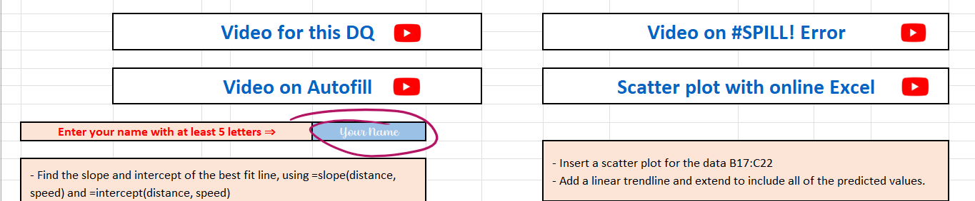

- Slope is explained here: https://support.microsoft.com/en-us/office/slope-function-11fb8f97-3117-4813-98aa-61d7e01276b9
. Intercept is explained here: https://support.microsoft.com/en-us/office/intercept-function-2a9b74e2-9d47-4772-b663-3bca70bf63ef
The formulas are shown below.
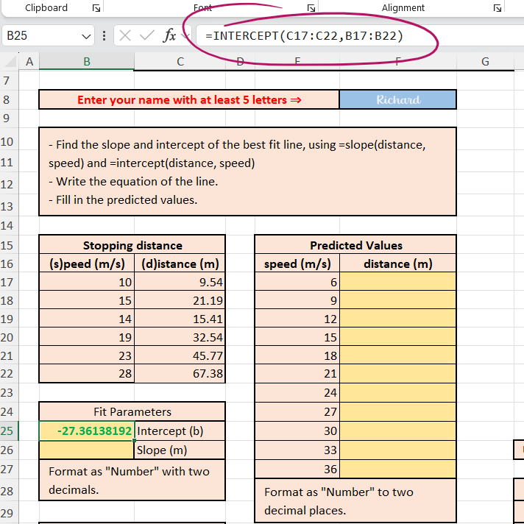
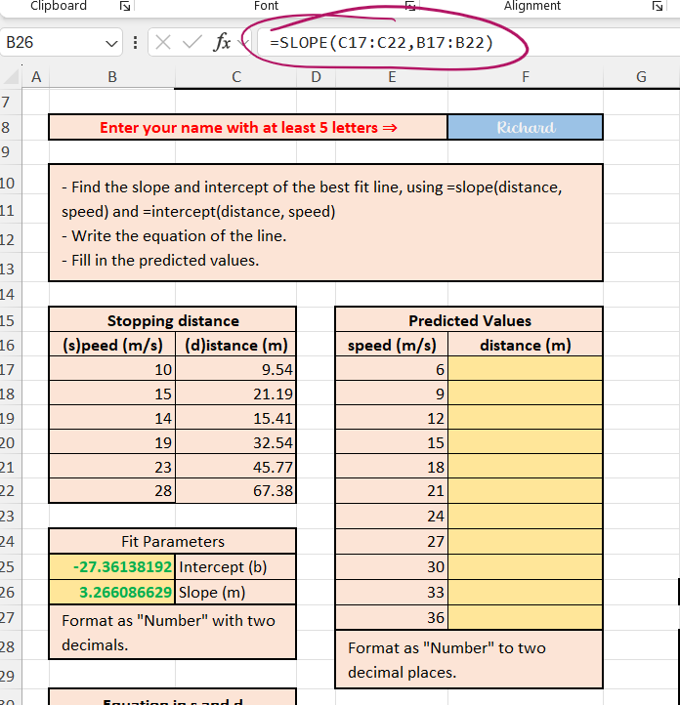
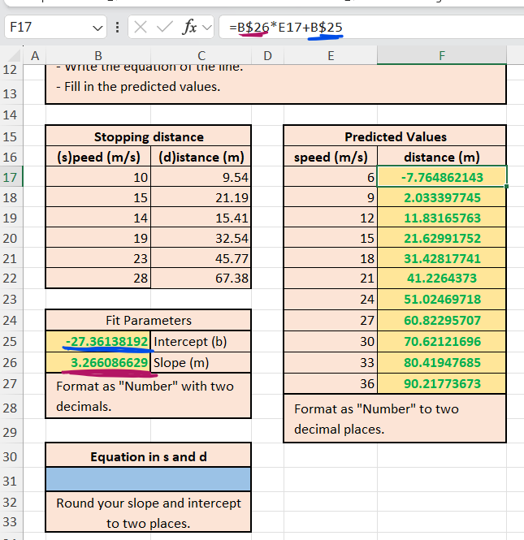
- Enter the formula in F17. As in the previous DQ, do not forget to use $. Also, make sure to drag the formula to fill out column F. Also, make sure to right-click the cells and choose “Format cells” to control the number of decimals.

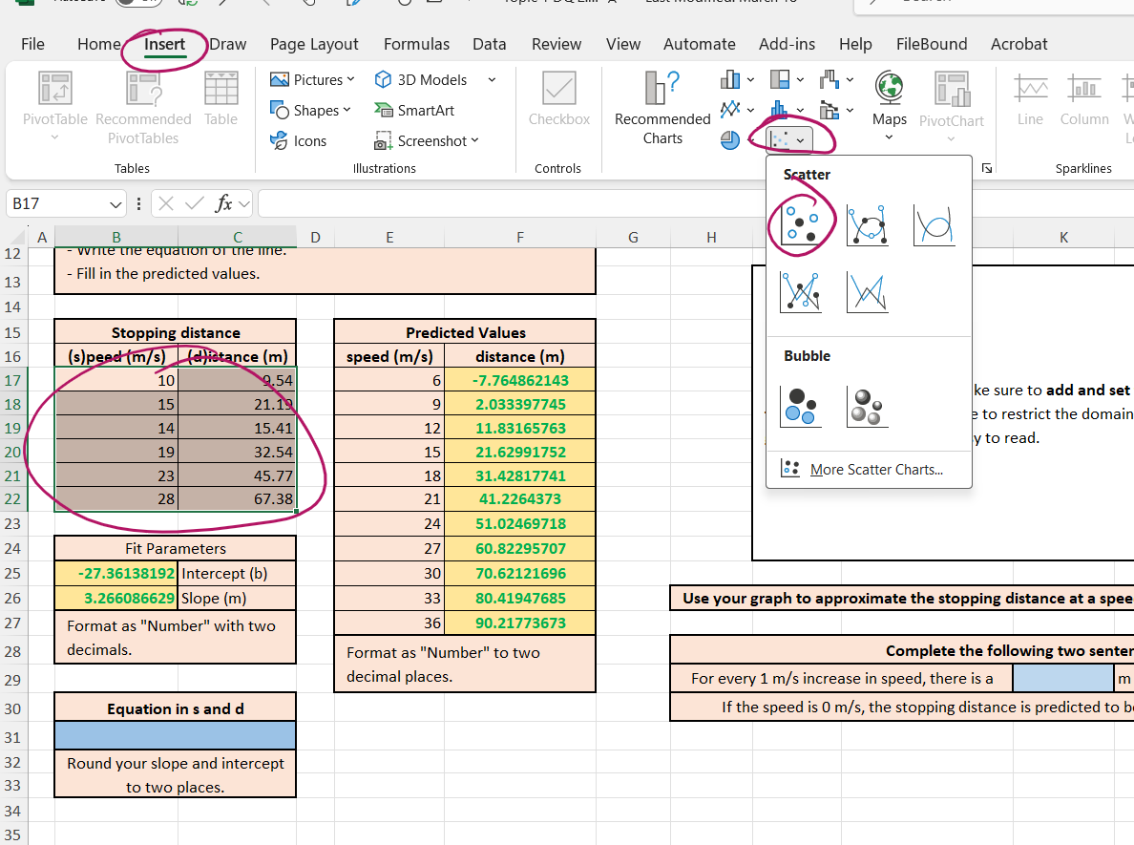
- Now, we make a scatter plot. Make sure to highlight both columns B and C and don’t forget to highlight speed and distance. Then, click “Insert” and choose the scatter plot notation.

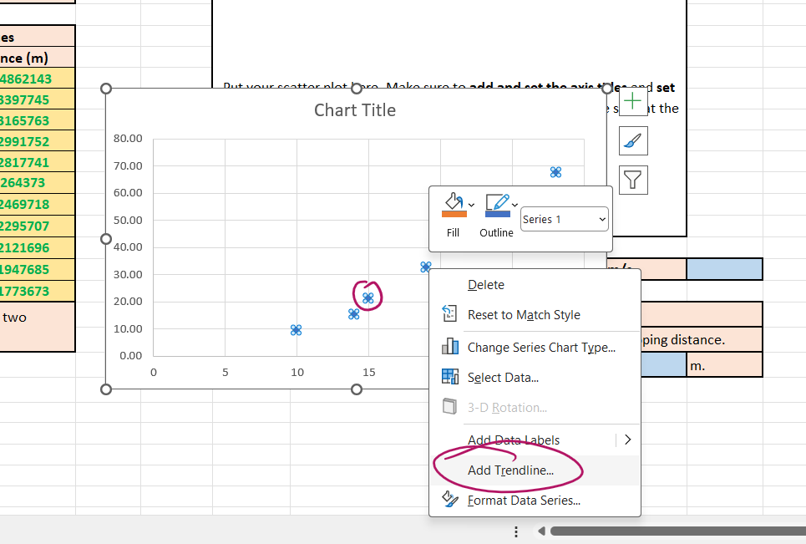
- Right-click a point and add a trendline.

- Right-click or double-click the trend line and choose “Format trendline.” Next, choose the appropriate amount for “Forward” (8 for our case, since 28 + 8 = 36) and “Backward” (4 for our case, since 10 – 4 = 6).
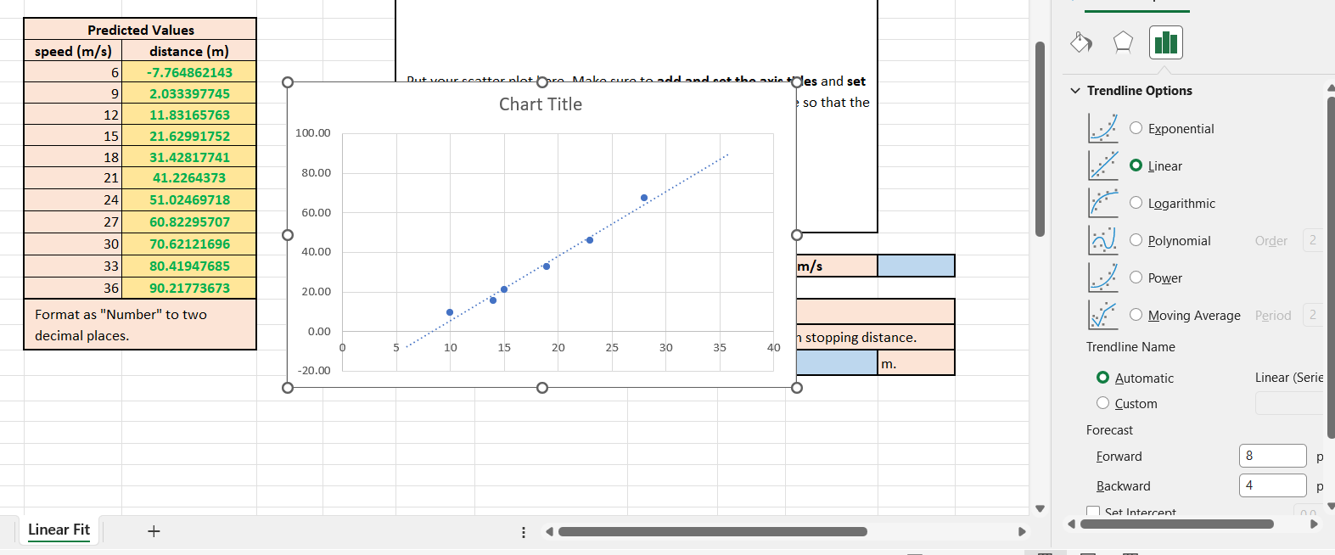

- As in the previous DQ, once you click +, there are options that enable you to edit your chart.

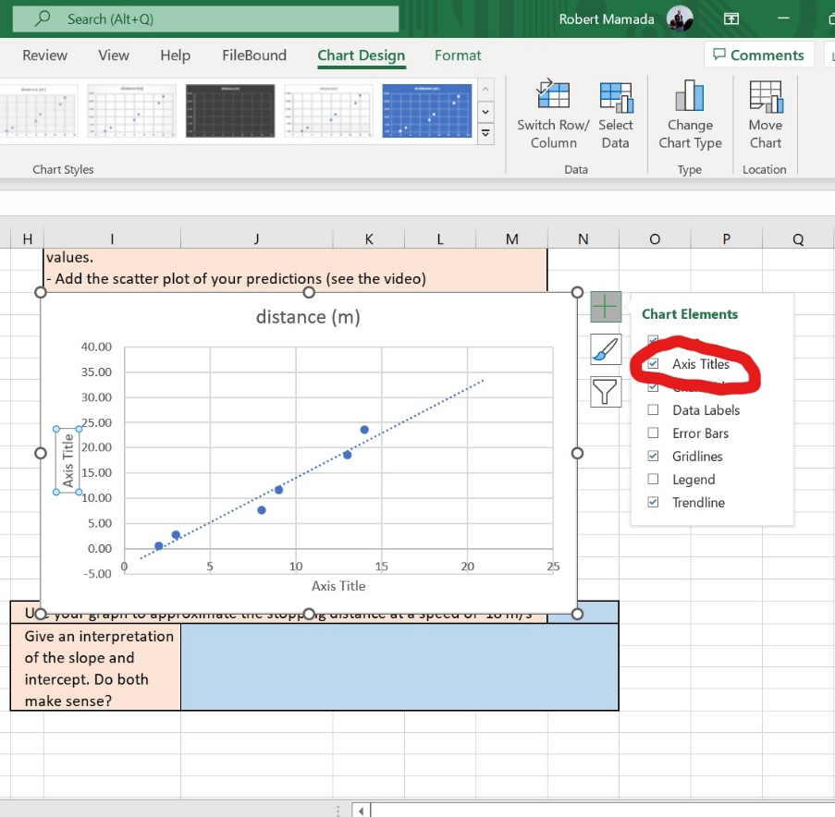

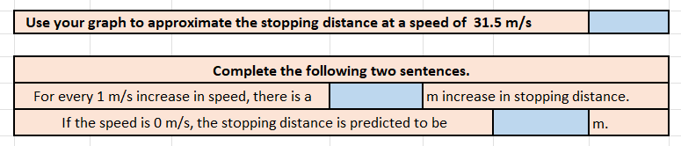
- Don’t forget to answer the blue areas.

- Format all numbers as requested.

